**Azure Active Directory**

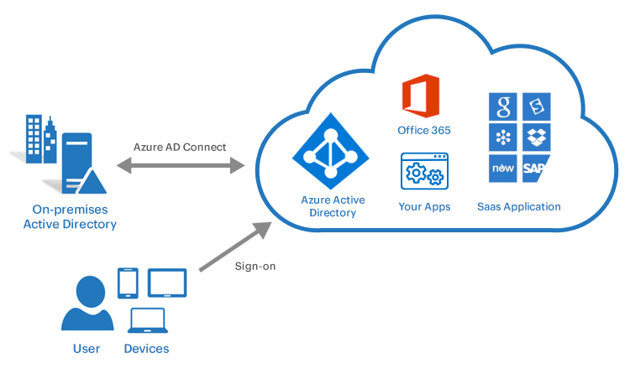

Azure Active Directory (Azure AD) is **Microsoft’s cloud-based identity and access management service** that helps employees sign in and access resources securely. It supports **single sign-on (SSO), multi-factor authentication, and conditional access** to protect users and data.

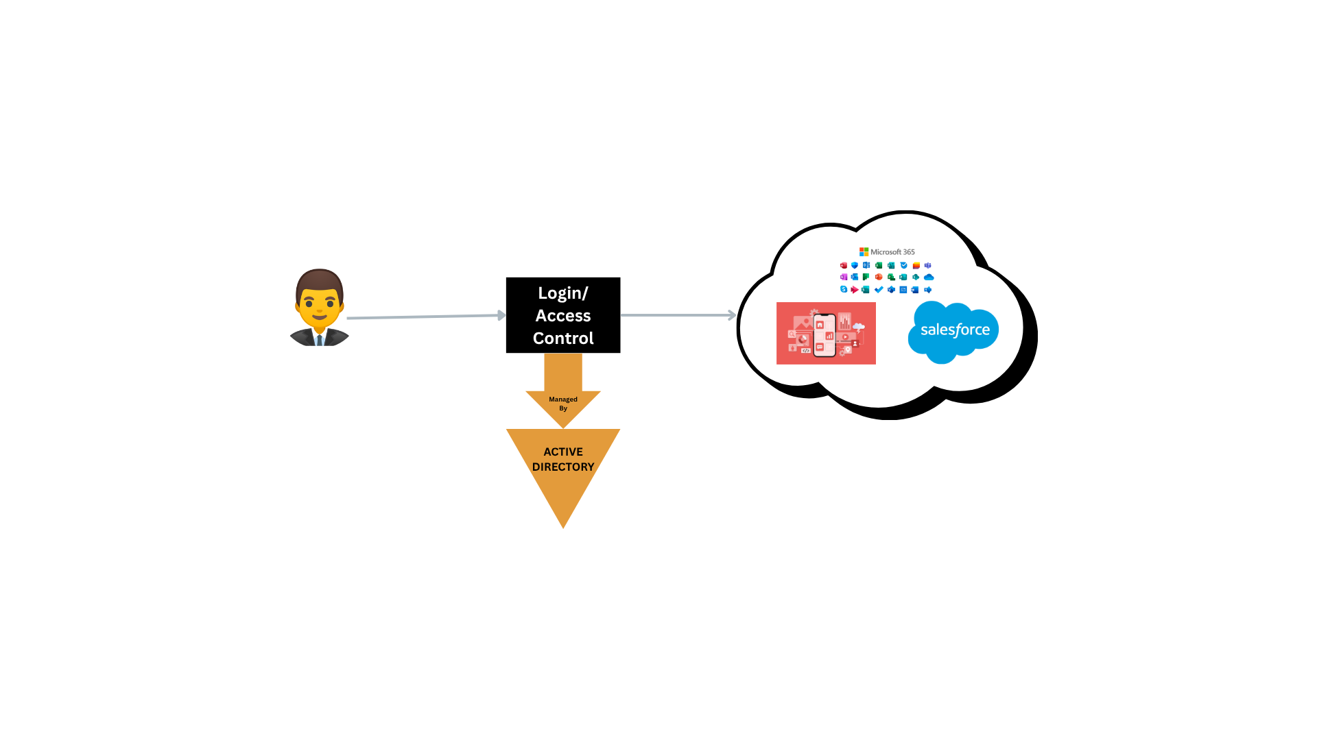

1. **User attempts to log in** to access cloud applications like **Microsoft 365** or **Salesforce**.
2. The **Login/Access Control** is **managed by Azure Active Directory**, which authenticates the user and grants secure access to those apps.